Spending on Influencer Marketing Rises
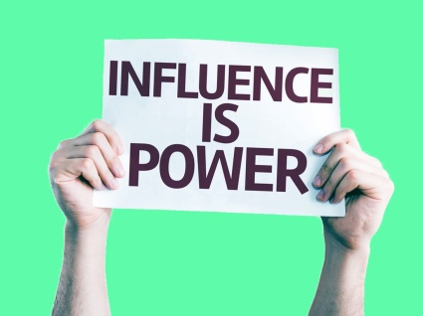
The popularity of influencer marketing is growing and more than 60% of both marketers and influencers report budget increases in the space, according to an Activate survey. A separate WhoSay survey also found a strong majority of marketers planning to raise their influencer budgeting.
eMarketer 6/29/18
https://www.emarketer.com/content/is-influencer-marketing-everything-it-can-be#
Image credit:
https://cdn-images-1.medium.com/max/1600/1*COcLlpB-Rznryxzl2Y5tLA.jpeg

