Streamers Go All In On Sports Despite Challenges
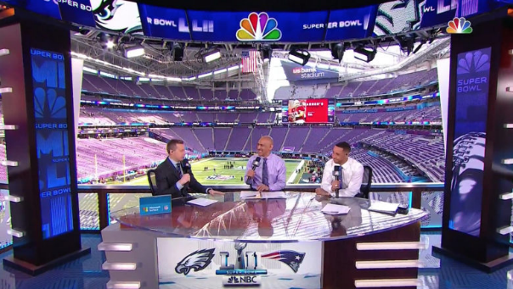
Studios, cable brands and digital platforms are investing heavily in sportscasting rights and infrastructure in an effort to attract increasingly fragmented television audiences. Mike Cavanagh, president of Comcast, says the company's peak bandwidth use shifted from Sundays to Thursdays when Amazon started its "Thursday Night Football" coverage.
The Hollywood Reporter 12/15/23
https://www.hollywoodreporter.com/business/business-news/nfl-mlb-nba-streaming-tv-sports-1235756577/
Image copyright:
https://www.newscaststudio.com/wp-content/uploads/2018/02/NCS_NBC-Super-Bowl-Studio_0007-780x440.jpg

