Leagues Balance Owned Media With Partner Deals
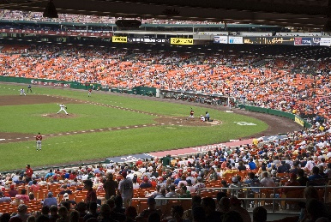
A growing number of sports leagues are trying to balance ownership with profits by streaming some games themselves while selling TV rights to companies such as Disney, Comcast and Apple. "No medium goes away, right? Radio didn't disappear when TV came, and TV isn't going to disappear because you can stream on the internet," notes Noah Garden, chief revenue officer for MLB.
The Hollywood Reporter 7/27/22
https://www.hollywoodreporter.com/business/business-news/pro-sports-dilemma-ownership-or-rich-tv-rights-deals-1235187009/
Image credit:
https://www.tripsavvy.com/thmb/zecA3NPnzXiD8Lfge5wNM-3c_fs=/3988x2670/filters:no_upscale():max_bytes(150000):strip_icc()/washington-nationals-baseball-team-playing-at-nationals-park-baseball-stadium--149695726-5a8168e36bf069003785d853.jpg

