Sports Leagues Court New Audiences With Digital Offerings
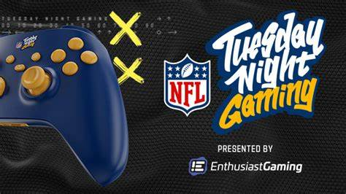
"Tuesday Night Gaming," a video game league from the NFL, is among a growing number of digital-focused events, courses and competitions that professional sports leagues are sponsoring. The organizations are trying to attract younger audiences and get them engaged with the franchises if not the sports themselves.
Axios 9.12.22
https://www.axios.com/2022/09/11/nfl-gaming-nba-2k-league-tgl-pga-tour

