Spotify Will Warn Of Misinformation, But Not Remove It
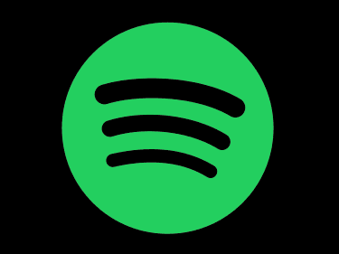
Spotify has announced it will place content advisories ahead of podcasts about COVID-19, but will not remove any material. Neil Young, Joni Mitchell and other artists have taken steps to remove their music from the service in protest of vaccine misinformation on "The Joe Rogan Experience," and Prince Harry and his wife Meghan have also voiced concerns about the platform, with which they have recently signed contracts.
The Associated Press 1/30/22
https://apnews.com/article/coronavirus-pandemic-entertainment-technology-health-business-4bf1b708c22ed5ca36709cd48d782c57

