Stadiums Go Mobile to More Fully Engage Fans
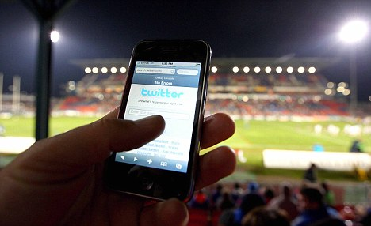
Stadiums across the country are focusing on mobile as much as on the on-field spectacle, adding connectivity and features that enhance the fan experience and encourage more spending. "Point-of-sales systems, ticket check, Wi-Fi, video, audio, internet, communications and a host of other things all need to work seamlessly for fans to have a great experience," said Shannon Miller, an IBM associate partner.
AdExchanger 9/20/17
https://adexchanger.com/mobile/mobile-data-key-new-generation-sports-fan/
Image source:
http://www.digital-football.com/wp-content/uploads/2013/04/article-1284597-0AF89E3B000005DC-158_468x286-1.jpg

