Stella Artois Uses Location History to Know When You Visit a Pub
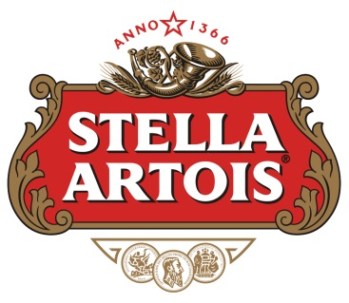
Stella Artois has run a campaign aiming ads at people based on the predicted likelihood that they'll stop by a bar soon. Stella ran mobile display and video ads through Blis, paying only when people exposed to the ads actually visit a pub, for around six weeks throughout the U.K.
Advertising Age 3.28.17
http://adage.com/article/datadriven-marketing/visit-pub-stella-artois-ad/308446/?utm_source=daily_email&utm_medium=newsletter&utm_campaign=adage&ttl=1491261238&utm_visit=113450

