Streaming, Interactive Boosting Weathercasts
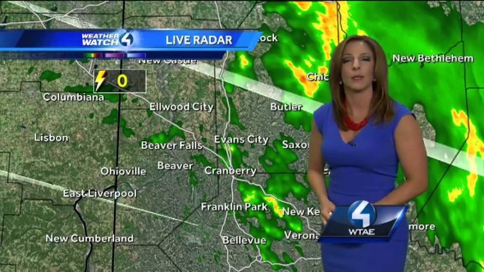
Enabled by the emergence of user-friendly platforms like Facebook, Periscope and Google Hangouts, stations are expanding their use of live streaming to complement regular on-air weather coverage and build a community around the coverage.
TVNewsCheck 5.4.16
http://www.tvnewscheck.com/article/94466/streaming-interactive-boosting-weathercasts?utm_source=Listrak&utm_medium=Email&utm_term=Streaming%2c+Interactive+Boosting+Weathercasts&utm_campaign=Streaming%2c+Interactive+Boosting+Weathercasts

