Streaming-First Consumers Erode Cable TV's Dominance
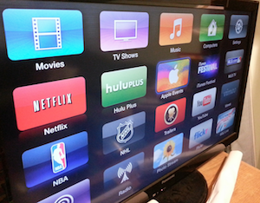
New figures from Raymond James reveal that 31% of internet users polled in November named a streaming service like Netflix or Hulu as their primary method of consuming video content. That was up from just 24% about a year ago. It was also a scant few percentage points behind the 35% who named cable as their chief means of watching video.
eMarketer 12.5.17
https://www.emarketer.com/content/streaming-first-us-households-gain-on-cable-tv?ecid=NL1001
Image credit:
http://themediaonline.co.za/wp-content/uploads/2015/02/Screenshot-2015-02-16-10.18.40.png

