Streaming Hits Record Share Of TV Viewing In June
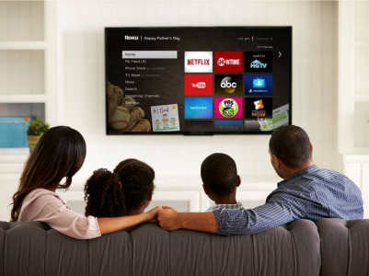
US viewers spent 33.7% of their time streaming in June, the format's highest percentage of the marker since Nielsen began its monthly measurements in May 2021 and up 1.8 percentage points from the prior month. Total viewership rose 2%.
Next TV/Broadcasting+Cable 7/21/22
https://www.nexttv.com/news/streamings-share-of-tv-viewing-rises-to-337-in-june-nielsen?utm_source=SmartBrief&utm_medium=email&utm_campaign=45863C53-9E40-4489-97A3-CC1A29EF491D&utm_content=446AE0AE-25EE-4A0E-B80E-94C7CD8A5957&utm_term=a25693a1-51b6-4112-bde4-56bd420e983f
Image credit:
https://www.opptrends.com/wp-content/uploads/2020/06/How-to-Choose-the-Best-TV-Streaming-Service.jpg

