Report: Streaming Players in 31% of US Households
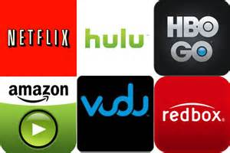
On-demand video streaming players are owned by 31% of US households with an Internet connection, with an additional 14% saying they plan to add one this year, Parks Associates data indicate. Devices such as the latest Roku 4, Apple TV and Amazon Fire TV have become more attractive by adding such features as voice activation, while Apple and Amazon have also included hub-like features that allow control for other smart devices from set-top boxes.
Philly.com 2/14/16
http://www.philly.com/philly/business/homepage/20160214_Cutting_the_Cable.html

