Survey: 6.8 Streaming Services Per US Household
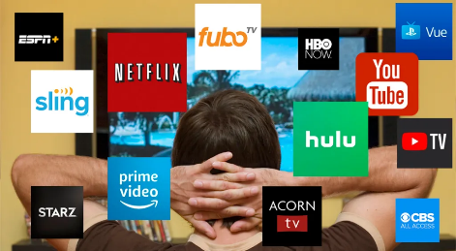
A recent survey from Kagan Consumer Insights claims the average American household uses 6.8 streaming services. Researchers say companies like HBO Max and Peacock have driven much of the growth in recent years.
TV Tech 6.21.22
https://www.tvtechnology.com/news/average-us-internet-home-uses-a-record-68-ott-services?utm_source=SmartBrief&utm_medium=email&utm_campaign=3E572E13-3FBC-11D5-AD13-000244141872&utm_content=41EC1F46-9B10-445E-90D1-CE9D0B206242&utm_term=a25693a1-51b6-4112-bde4-56bd420e983f
Image credit:
https://i2.wp.com/tccpro.net/gettcc/wp-content/uploads/2019/08/streaming-services.jpg?resize=1024%2C562&ssl=1

