Streaming TV Usage Nearly Doubles in Less Than 2 Years
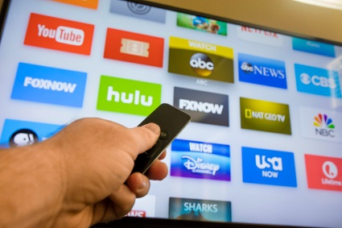
Using data from the Nielsen-owned Gracenote (which powers TV listings guides and search functions for on-demand providers), the company determined that in 2019 alone, a mind-boggling 646,152 unique program titles were available across every linear and streaming outlet. That's every series (current and past), movie, special, news program, sports telecast and kids' show that ran on one platform or another, from broadcast networks to Netflix to niche streaming services.
The Hollywood Reporter 2.11.20
https://www.hollywoodreporter.com/live-feed/streaming-tv-usage-doubles-2-years-nielsen-says-1278637?utm_source=Listrak&utm_medium=Email&utm_term=Nielsen%3a+Streaming+Nearly+Doubles+In+2+Years&utm_campaign=Tegna+4Q+Revenue+Climbs+8%25
Image credit:
https://cdlnws.a.ssl.fastly.net/image/upload/f_auto,q_auto/v1522338717/Streaming_TV_Apps_kyotau.jpg

