Studios Calculate Pandemic Risks to Resume Production
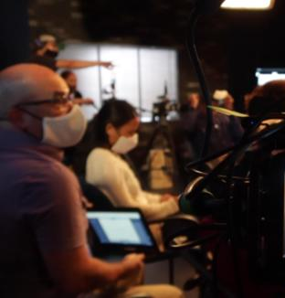
Television and movie studios are eyeing plans to resume production with strict safety measures in place as they weigh pandemic risks against the costs of lengthy delays and shutdowns. A number of studios have implemented temporary production holds, pushing back continued filming until mid-January.
Variety online 1.4.21
https://variety.com/2021/tv/news/extended-los-angeles-production-shutdown-not-seen-likely-1234878541/
Image credit:
https://img.particlenews.com/image.php?type=thumbnail_580x000&url=2Ch2iL_0Y8nFYo600

