Studios Eye Restarting Production with Safety in Mind
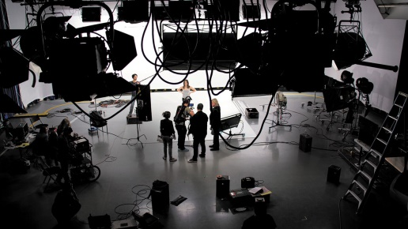
Television and movie studios shut down by the coronavirus pandemic are developing strategies to protect crew and cast members when the time comes to resume production. Studios are working in partnership with industry unions and production facilities to develop standards for reopening, and will reportedly meet with health experts in Los Angeles County to discuss challenges and solutions.
The Hollywood Reporter 4.27.20
https://www.hollywoodreporter.com/news/as-hollywood-maps-return-new-set-protocols-take-center-stage-1292071
Image credit:
https://cdn1.thr.com/sites/default/files/2018/08/aftrs_open_day30dpi-h_2018.jpg

