Study Highlights Need for More Diversity in PR
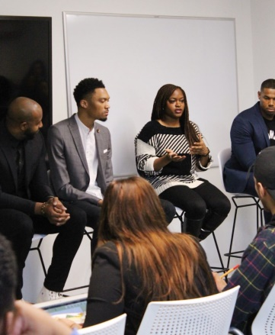
PR Week research reveals that only 23% of the total workforce at PR firms was non-white in 2019 and these individuals only represented 13% of the C-suite, which trails the ethnic composition of the US population, according to US Census figures. PR executives concur that more work needs to be done regarding inclusivity, with Weber Shandwick CEO Gail Heimann noting, "The simple, disheartening truth is we aren't nearly as diverse as we should be."
PRWeek 6.19.20
https://www.prweek.com/article/1687139/no-excuses-pr-firms-progress-diversity
Image credit:
https://source.oglethorpe.edu/files/2020/03/6-844x1024.jpg

