Powell: Congress Needs to Subsidize Broadband Services
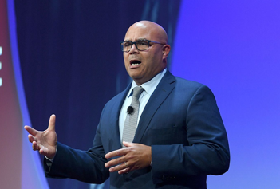
Michael Powell, president of NCTA--The Internet & Television Association, told a Hispanic tech summit that Congress should subsidize closing the digital divide. He suggested broadband should be treated as part of the "social safety net," and said that access is a civil rights concern.
Next TV/Multichannel News 12/3/20
https://www.nexttv.com/blogs/powell-broadband-may-need-to-be-part-of-social-safety-net?utm_source=SmartBrief&utm_medium=email&utm_campaign=3E572E13-3FBC-11D5-AD13-000244141872&utm_content=505582EC-08D3-4A63-A147-83ADB28C46E3
Image credit:
https://www.ncta.com/sites/default/files/2020-03/michael_powell_speech.png

