Sundance Honors Filmmakers From Marginalized Communities
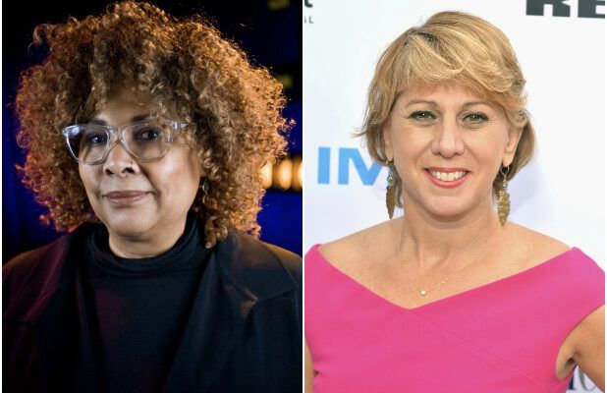
The Sundance Film Festival's 6th Annual Horizon Awards is lauding Zawan Mahmoud and Viviane Charlestin, two female up-and-coming student filmmakers from marginalized communities. The award recipients are set to receive grants and mentorship from Sundance and Hollywood professionals as they continue to nurture their film careers.
The Credits 1/29/20
https://www.motionpictures.org/2020/01/celebrating-the-sundance-film-festivals-6th-annual-horizon-awards/
Image credits:
https://s.yimg.com/lo/api/res/1.2/mAtNnNJYg5sBz79lZGL13g--/YXBwaWQ9YXBlY21lZGlhO3NtPTE7dz02MTg7aD00MDA-/https://media.zenfs.com/en-US/thewrap.com/d2a17524168a1a8638b7227ccf5e851c

