AT&T To Pay DirecTV Up To $2.1 Billion for NFL Sunday Ticket Losses
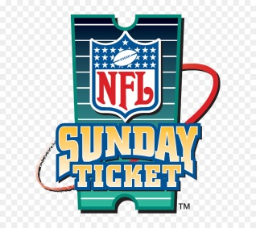
AT&T no longer owns DirecTV but it has agreed to pay up to $2.1 billion for losses resulting from its NFL Sunday Ticket contract. It said that it was paying the new DirecTV up to a cap of $2.1 billion for losses resulting from the Sunday Ticket agreement. The rights deal expires at the end of the 2022 regular season.
NextTV 9.9.21
https://www.nexttv.com/news/atandt-to-pay-directv-up-to-dollar21-billion-for-nfl-season-ticket-losses?utm_source=Listrak&utm_medium=Email&utm_term=AT%26amp%3bT+To+Pay+DirecTV+Up+To+%242.1+Billion+For+NFL+Sunday+Ticket+Losses&utm_campaign=Talking+TV%3a+Jay+Leno%27s+Latest+Bet
Image credit:
https://banner2.cleanpng.com/20180724/yfr/kisspng-directv-nfl-sunday-ticket-enhanced-service-sport-a-sunday-5b57081e127465.1753852115324303660756.jpg

