Super Bowl: $4.5 Billion in Ad Spending Over 50 Years
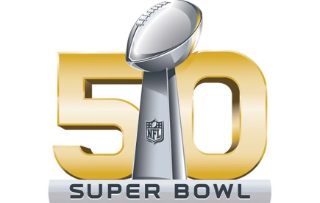
Ad spending for commercials during the game on Feb. 7's Super Bowl 50 broadcast on CBS will total a record $377 million, according to Ad Age Datacenter's estimate. That's more than was spent on the Super Bowl in the 1960s, '70s and '80s combined ($299 million).
Advertising Age 1.26.16
http://adage.com/article/news/super-bowl-supersized-4-5-b-ad-spending-50-years/302180/?utm_source=daily_email&utm_medium=newsletter&utm_campaign=adage&ttl=1454415323

