Surprise: You Can Still Buy a Super Bowl Spot
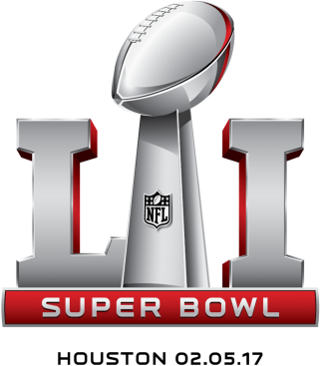
That’s a surprise, given that the game has sold out months in advance the past few years. But buyers say a combination of factors, including higher pricing and general uncertainty about TV advertising right now, have led to lower demand this year.
MediaLife 1.31.17
http://www.medialifemagazine.com/surprise-can-still-buy-super-bowl-spot/

