'90s Video Game Treasures Set To Sell In Nebraska
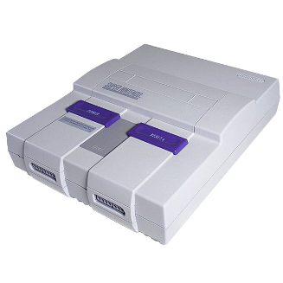
After the rediscovery of hundreds of sealed Super Nintendo and Sega Genesis cartridges from a closed Nebraska video game store, the collection -- including a nearly perfectly preserved Chrono Trigger game -- is anticipated to fetch six figures, according to Chris Kohler, a collector and the editorial director at Digital Eclipse. Despite missing out on the pandemic's vintage game sales spike, individual games from the collection are expected to sell for up to $10,000, with the possibility of the entire collection being sold as a bundle for a bundle.
National Public Radio (11/29)
https://www.npr.org/2023/11/29/1215866633/video-games-nintendo-nebraska-collection-sega-genesis
Image copyright:
https://www.ebay.com/itm/276191222605?chn=ps&_trkparms=ispr%3D1&amdata=enc%3A1BBtoCSNjQV-8s4N-APND5g32&norover=1&mkevt=1&mkrid=711-213727-13078-0&mkcid=2&itemid=276191222605&targetid=4580428016871225&device=c&mktype=&googleloc=&poi=&campaignid=603247657&mkgroupid=1229254994528356&rlsatarget=pla-4580428016871225&abcId=9316139&merchantid=51291&msclkid=c8fff3d01e401aa370b396bf8e70a759

