Survey Shows Spike In Violence Against Journalists
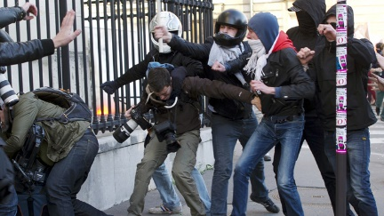
Broadcast journalists faced record levels of violence and harassment during the past year and 86% of news directors implemented changes in an effort to keep their staff safe as they covered civil unrest and protests amid the pandemic, a survey from the Radio Television Digital News Association indicates. The role of broadcast journalists in covering pivotal historical moments "has never been more important," National Association of Broadcasters CEO Gordon Smith says.
Next TV/Broadcasting+Cable 4/28/21
https://www.nexttv.com/news/rtdna-survey-finds-unprecedented-attacks-on-broadcast-journalists
Image credit:
https://img.rt.com/files/news/21/82/00/00/un-journalists-security-council.si.jpg

