T-Mobile adds Streaming Services to Binge On Program
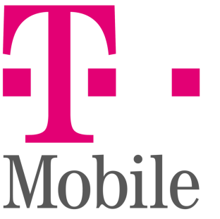
T-Mobile has announced additional streaming services supported by its Binge On program, which allows users to stream music and video without using data. Additions to the program include NBC, Univision, Spotify, Tidal and Radio Disney.
CNET 5/17/16
http://www.cnet.com/news/t-mobiles-binge-on-adds-nbc-spotify-google-play-music/

