**He's licked! Taco Bell fires shell-licking employee**

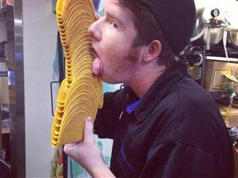The unidentified employee and his co-worker photographer are no longer working at the involved Taco Bell franchise, the company announced on its website. A picture posted on Facebook had shown the employee licking a tall stack of shells and the social media masses were pretty grossed out.

***NBC News 6.5.13***

<http://www.nbcnews.com/business/hes-licked-taco-bell-fires-shell-licking-employee-6C10205122>