Taiwan Is Beating Political Disinformation. The West Can Too.
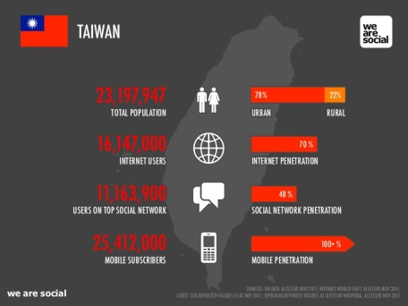
Taiwan takes a whole-of-society approach to fighting disinformation. Its civic technology community works with social media companies, like the island’s popular messaging service Line, to identify, debunk, and downrank viral conspiracy theories on social media platforms.
Foreign Policy 11.10.20
https://foreignpolicy.com/2020/11/11/political-disinformation-taiwan-success/?utm_source=API+Need+to+Know+newsletter&utm_campaign=b02ca5a69b-EMAIL_CAMPAIGN_2020_11_13_01_33&utm_medium=email&utm_term=0_e3bf78af04-b02ca5a69b-31697553
Image credit:
https://image.slidesharecdn.com/wearesocialsguidetosocialdigitalmobileintaiwandec2011-111219184017-phpapp01/95/we-are-socials-guide-to-social-digital-and-mobile-in-taiwan-dec-2011-3-728.jpg?cb=1325985529

