Talk Radio, Spoken Word Podcasts Gain Popularity
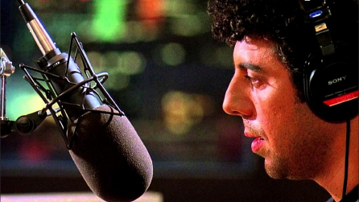
Audiences for spoken word audio content have grown by 55% over the last nine years, and half of spoken word listeners spend more time on that content than with music, according to the Spoken Word Audio Report from Edison Research and NPR. Broadcast radio makes up a significant portion of spoken word consumption, accounting for 62% of in-car 41% of at-home listening.
Inside Radio 11/10/23
https://www.insideradio.com/free/spoken-word-audio-consumption-hits-new-highs-with-more-listening-done-at-home/article_4a3fafc6-7f9f-11ee-9c6a-c3cb3695cb9f.html
Image credit:
https://1.bp.blogspot.com/-DpGeu6-FZC0/XY4HaMsRs6I/AAAAAAAAceI/MUqWCzFTpoA2tWAHxQsaEL42hvJKenPbwCEwYBhgL/s1600/Talk%2BRadio%2B2.jpg

