Live.ly Provides Teen Influencers with Money-Making 0pportunities
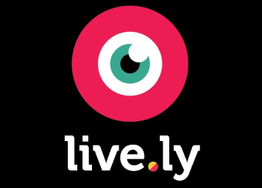
Live.ly had pushed Periscope from its spot as the top iPhone live-streaming app within three months of launching, per SurveyMonkey Intelligence. Teen influencers are reveling on the platform, where fans can pay money to send them virtual gifts in the hope of live interaction, which can give creatives such as 15-year-old Bryce Xavier between $100 and $1,200 per broadcast.
The New York Times 6/6/17
https://www.nytimes.com/2017/06/06/arts/lively-the-teenage-life-streamed.html?WT.mc_id=SmartBriefs-Newsletter&WT.mc_ev=click&ad-keywords=smartbriefsnl&_r=0

