Texas Principal Censors Paper, Ousts Award-Winning Adviser
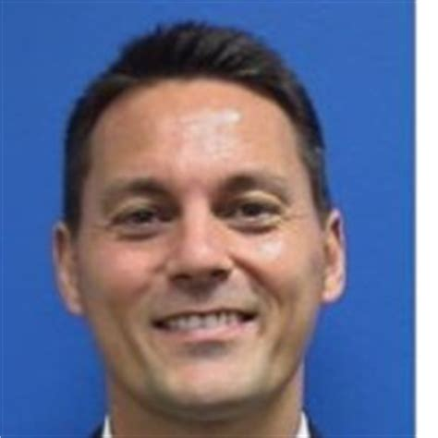
After censoring the Eagle Nation Online three times this academic year over concerns that stories made the school look bad, the principal of Prosper (Texas) High School, located in the Dallas-Fort Worth metro area, will not renew the contract of a nationally acclaimed newspaper and yearbook adviser.
Student Press Law Center 5.23.18
http://www.splc.org/article/2018/05/prosper-high-school?utm_source=Student+Press+Law+Center+newsletter&utm_campaign=e4a51d66a1-EMAIL_CAMPAIGN_4_26_2018_COPY_02&utm_medium=email&utm_term=0_8fab1c40ea-e4a51d66a1-138474105
Image credit:
https://www.bing.com/images/search?view=detailV2&ccid=bxaspgJd&id=09EF329160E1BEBA1978B598F55F47E84BCBC4E1&thid=OIP.bxaspgJdY0oiZZoZeNFGewHaHa&mediaurl=https%3a%2f%2fmedia.licdn.com%2fmpr%2fmpr%2fshrinknp_200_200%2fp%2f7%2f005%2f02e%2f370%2f13fa512.jpg&exph=200&expw=200&q=John++Burdett+%2b+principal+of+Prosper+(Texas)+High+School%2c&simid=608029812225675013&selectedIndex=2&ajaxhist=0

