Texas Radio Pulls Around-The-Clock Duty to Keep Communities Informed
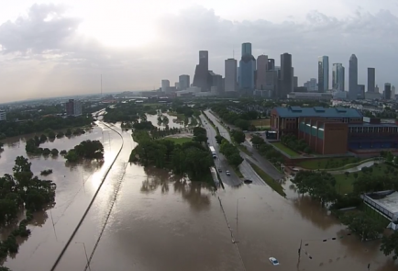
Cox Media, iHeart Media and CBS radio are among the Texas stations providing nonstop coverage of Hurricane Harvey and its aftermath to keep communities informed; with some employees losing their vehicles and leaving their homes open to destruction as they stay on the air. "NAB salutes Texas and Gulf Coast broadcasters in the path of Hurricane Harvey who are devoting enormous resources to keeping people safe," National Association of Broadcasters President Gordon Smith said of the efforts.
Inside Radio 8/28/17
http://www.insideradio.com/free/broadcasters-withstand-harvey-s-wrath-keep-communities-informed/article_8fb75596-8bc6-11e7-8f61-33c1d45d0226.html
Image credit:
http://legalinsurrection.com/wp-content/uploads/2015/05/HoustonFlood-Houston-Flooding-flooding-deaths-galleria-flooded-flooding-video-footage-100-year-flood-rainfall-e1432670590174.png

