The AP and Report for America are Creating 14 New Statehouse Jobs
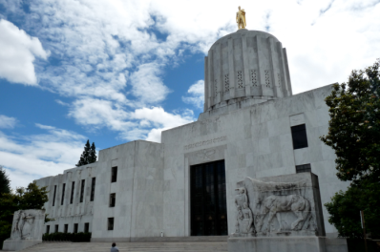
The collaboration will bring more coverage to Colorado, Indiana, Kansas, Michigan, Minnesota, Mississippi, Nevada, New Mexico, North Carolina, Ohio, Oregon, South Carolina and Utah. The positions, mostly funded by the AP and RFA, will last for 18 months and begin next June.
Poynter 11.25.19
https://www.poynter.org/reporting-editing/2019/the-ap-and-report-for-america-are-creating-14-new-statehouse-jobs/?utm_source=API+Need+to+Know+newsletter&utm_campaign=04e61b1082-EMAIL_CAMPAIGN_2019_12_03_01_33&utm_medium=email&utm_term=0_e3bf78af04-04e61b1082-31697553
Image credit:
https://deadstate.org/wp-content/uploads/2016/05/Screen-Shot-2016-05-19-at-9.25.52-AM.png

