The Benefits, Challenges of Free Speech
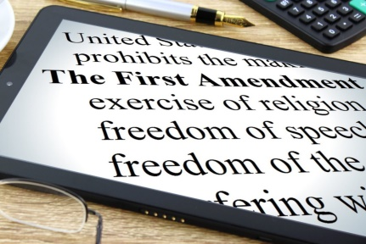
It's important for PR professionals to remember that the First Amendment affords communications professionals and consumers the ability voice opinions, which can often include push back, according to Lata Nott, an attorney and Fellow with the Freedom Forum. In this Q&A in advance of her PRSA annual conference keynote, Nott discusses speech disruptions created by social media, considerations for political conversations and how to handle controversial employee social posts.
PRSAY 9/28/20
http://prsay.prsa.org/2020/09/28/icon-2020-preview-lata-nott-on-communicators-first-amendment-freedoms-and-expensive-attention/
Image credit:
https://www.thebluediamondgallery.com/dictionary/the-first-amendment.jpg

