The Biggest Spenders In The Podcast Ad Boom
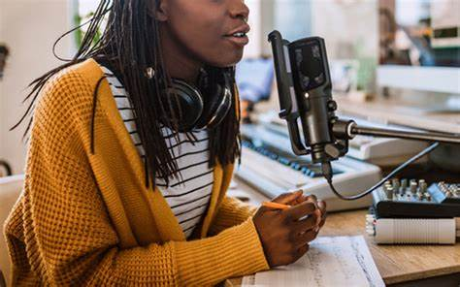
BetterHelp bested other US podcast advertisers in 2021 and spent $76.9 million on podcast placements that year. This was nearly triple the outlays of NBCUniversal, the second-biggest spender, at $27.7 million. All told, the top 10 podcast advertisers invested close to $300 million.
eMarketer 3.8.22
https://www.emarketer.com/content/biggest-spenders-podcast-ad/?IR=T&utm_source=Triggermail&utm_medium=email&utm_campaign=II20220309PodcastAdsCOTD&utm_content=Final&utm_term=COTD%20Active%20List
Image credit:
https://omnicommediagroup.com/wp-content/uploads/2020/07/Podcast.jpg

