The Case Against Free Social Media
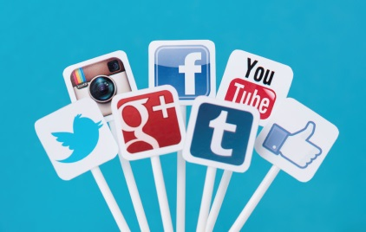
Free-to-use social networks necessarily wind up turning users into products and commoditizing personal data, Zeynep Tufekci writes. She suggests networks let users pay a fee in exchange for better privacy, less tracking and more control over their online experience.
The New York Times 6/4/15

http://www.nytimes.com/2015/06/04/opinion/zeynep-tufekci-mark-zuckerberg-let-me-pay-for-facebook.html?action=click&pgtype=Homepage&module=opinion-c-col-right-region&region=opinion-c-col-right-region&WT.nav=opinion-c-col-right-region&_r=0

