The Decline of College Newspapers
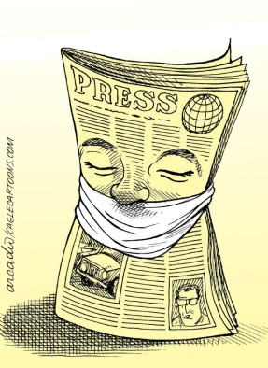
Some college administrators fail to understand the basic purpose of the free press. “Sometimes the administration wants the paper to be a PR outlet for the university,” says Evans, the president of the College Media Association. LoMonte goes further, arguing that many administrations see their campus newspapers as a liability, not an asset.
The Atlantic 8.23.19
https://www.theatlantic.com/ideas/archive/2019/08/death-college-newspapers/595849/?utm_source=API+Need+to+Know+newsletter&utm_campaign=b39eb6eb5c-EMAIL_CAMPAIGN_2019_08_23_01_56&utm_medium=email&utm_term=0_e3bf78af04-b39eb6eb5c-31697553
Image credit:
https://lucindafranks.com/wp-content/uploads/2015/08/Press-and-Censorship-by-Arcadio-Esquivel-Cagle-Cartoons-La-Prensa-Panama-1.jpg

