The Flourishing Business of Fake YouTube Views
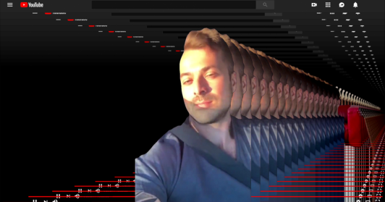
Martin Vassilev makes a good living selling fake views on YouTube videos. His website, 500Views.com, connects customers with services that offer views, likes and dislikes generated by computers, not humans. When a supplier cannot fulfill an order, Mr. Vassilev — like a modern switchboard operator — quickly connects with another.
The New York Times 8.11.18
https://www.nytimes.com/interactive/2018/08/11/technology/youtube-fake-view-sellers.html?rref=collection%2Fsectioncollection%2Ftechnology&utm_source=Listrak&utm_medium=Email&utm_term=A+Flourishing+Business+In+Fake+YouTube+Views&utm_campaign=RTDNA+Urges+Support+Of+Free+Press+Campaign
Image credit:
https://static01.nyt.com/images/2018/08/02/technology/00Youtube-Promo/00Youtube-Promo-facebookJumbo.png

