The GateHouse Takeover of Gannett Has Been Finalized
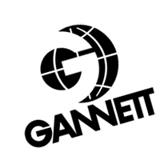
GateHouse is the acquiring partner, though it is choosing to operate the new company under the Gannett name and will preserve the USA Today brand. The company did not supply a figure for the total value of the deal. But including Gannett debt that GateHouse assumes, it appears to be roughly $2 billion.
Poynter 8.5.19
https://www.poynter.org/business-work/2019/the-gatehouse-takeover-of-gannett-has-been-finalized/?utm_source=API+Need+to+Know+newsletter&utm_campaign=eefc591eea-EMAIL_CAMPAIGN_2019_08_06_12_18&utm_medium=email&utm_term=0_e3bf78af04-eefc591eea-31697553

