The Journey Home
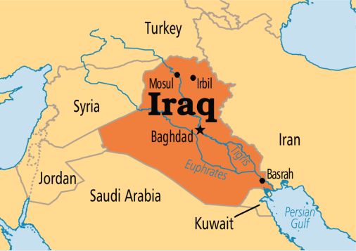
In February 2019, Zahra traveled back to her homeland, Iraq, to reunite with her father’s family after a 20-year separation. In Baghdad, Zahra rediscovered herself being immersed in an environment radiating in Middle Eastern culture. Walking Iraq’s streets humanized the people she’d grown up watching on TV and dismantled stereotypes reiterated throughout her upbringing.
Pulitzer Center August 2019
http://www.pulitzercenter.org/projects/journey-home

