The Market for Shorter, Mobile-First Programming is Not Materializing
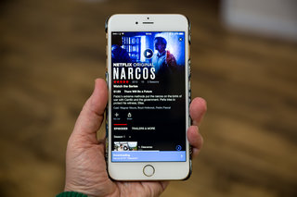
While media and entertainment companies can still make money from selling shows to Quibi and Snapchat or distributing series on Facebook and YouTube in exchange for advertising revenue, that money is not enough to keep a company in business. “The YouTube game is so difficult to make work financially,” said a second short-form video producer.
Digiday 1.29.20
https://digiday.com/media/market-shorter-mobile-first-programming-isnt-materializing/?utm_source=API+Need+to+Know+newsletter&utm_campaign=4ebf54f81f-EMAIL_CAMPAIGN_2020_01_30_01_17&utm_medium=email&utm_term=0_e3bf78af04-4ebf54f81f-31697553
Image credit:
https://cdn.pocket-lint.com/r/s/320x/assets/images/139186-tv-news-how-to-download-netflix-movies-and-tv-shows-on-your-phone-or-tablet-image6-4OrSMyAjW0.jpg?v1

