The Micheaux Project Aims to Help Minorities Seek Entertainment Journalism Careers
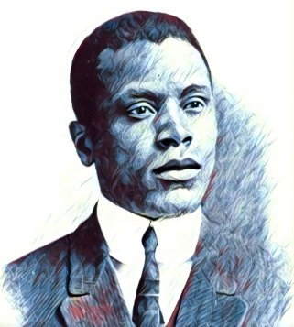
The Micheaux Project, created through a joint effort of Variety, the African American Film Critics Association and the Los Angeles Center for Enriched Studies, has been set up to encourage "high school students from underrepresented communities to consider careers as entertainment journalists and critics," Variety says.
Variety online 7.29.20
https://variety.com/2020/biz/news/micheaux-project-outreach-program-high-school-1234719255/
Image credit:
https://davidfwalker.com/wp-content/uploads/2015/02/oscar-m.jpg

