The Most Powerful People in Entertainment 2019
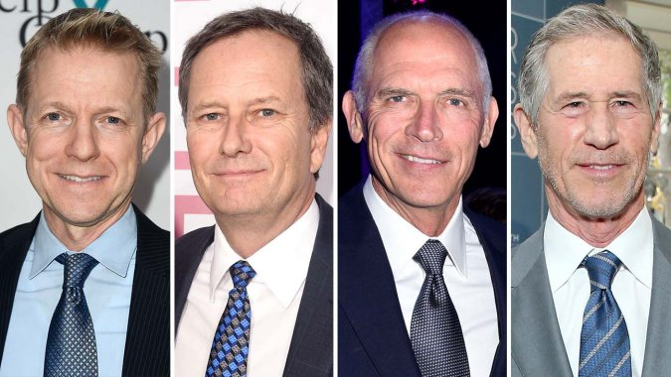
In a roller-coaster year of megamergers and megadeals, the ranking of showbiz’s top execs, makers and stars sees big moves and a more dynamic (and diverse) group of powerhouses as the Obamas join Netflix, Phoebe Waller-Bridge ignites the town's creatives and J.Lo hustles her way onto the ultimate industry A list.
The Hollywood Reporter 10.16.19
https://www.hollywoodreporter.com/lists/thr-100-hollywood-reporters-powerful-people-entertainment-1246527/item/thr-100-2019-taika-waititi-1246504?utm_source=Listrak&utm_medium=Email&utm_term=The+Most+Powerful+People+In+Entertainment&utm_campaign=Efficiencies+Key+To+Surviving+Media+Fragmentation
Image credit:
https://www.rocketnews.com/wp-content/uploads/2019/10/kevin_beggs_michael_burns_joe_drake_and_jon_feltheimer-split-getty-h_2019-1.jpg

