The New ASCAP Deal
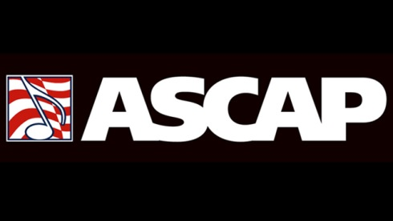
The agreement covers 2017 to 2021. It provides for increases in the rates paid by radio stations to perform music by ASCAP members via terrestrial, over-the-air broadcasts as well as certain digital transmissions and, for the first time, expressly affirms the percentage share of radio performances represented by ASCAP.
RadioInk 12.15.16
http://radioink.com/2016/12/15/ascap-rmlc-cut-new-deal/?utm_source=ActiveCampaign&utm_medium=email&utm_content=Why+is+Radio+Cheering+The+Departure+of+This+FCC+Chairman%3F&utm_campaign=Friday+-+Wheeler+Out

