The New Gear VR Will Work With Any new Samsung Phone
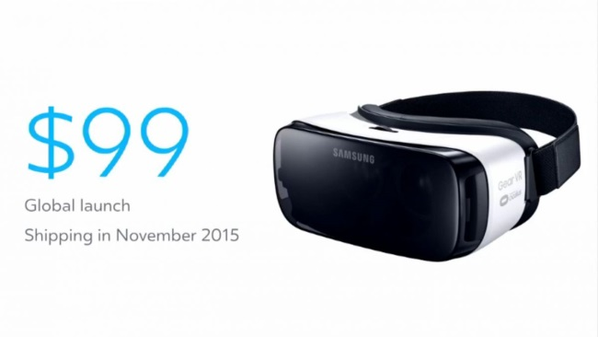
Samsung and Oculus have announced a new Gear VR mobile virtual reality headset, and it's coming before Black Friday. The latest Gear VR - priced at $99 - will work with Samsung's entire 2015 line of smartphones.
The Verge 9.24.15
http://www.theverge.com/2015/9/24/9392037/samsung-gear-vr-oculus-connect-2015

