The Pandemic Presents an Opportunity for Esports Viewership
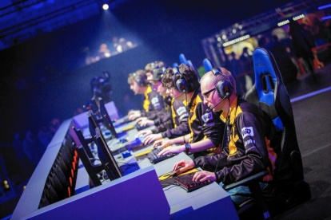
Thanks to their structure, leagues were able to pivot easily to online-only gameplay with remote production and speedily resumed their seasons. ESPN partnered with Riot Games to become the official linear platform for the League of Legends Championship Series (LCS) Spring Split Playoffs and held an “Esports Day,” for which it ran 12 hours of amateur and professional gaming tournaments on ESPN2.
eMarketer 8.26.20
https://www.emarketer.com/content/pandemic-presents-opportunity-esports-viewership?ecid=NL1001
Image credit:
http://powerupgaming.co.uk/wp-content/uploads/esports-1024x683.jpg

