The Rise of Influencer Bots and What it Means for Brands
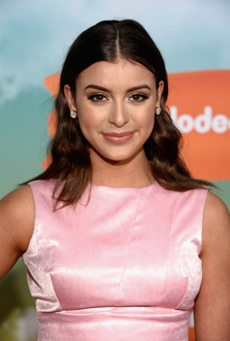
CoverGirl teamed with Automat and The Amplify to create a chatbot version of digital influencer Kalani Hilliker on Kik, resulting in 91% of users viewing the bot positively and a 14-times spike in social engagement compared with the influencer's actual posts.
The Drum (Glasgow, Scotland) 1/18/17
http://www.thedrum.com/news/2017/01/18/how-influencer-chatbots-could-close-the-gap-between-content-and-commerce

