The Rise of Mobile Could Create “A Second-Class Digital Citizenship”
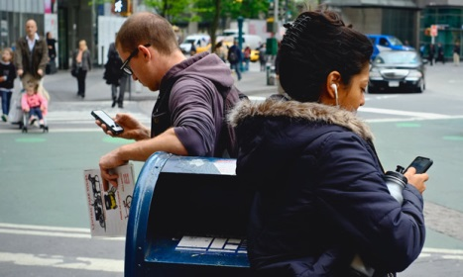
Using eye-tracking software, researchers were able to monitor how people engaged with news on their phones. Their conclusion: “We found that, relative to computer users, mobile users spent less time reading news content and were less likely to notice and follow links and to do so for longer periods of time,”
Nieman Lab.org 8.30.16
http://www.niemanlab.org/2016/08/the-rise-of-mobile-could-create-a-second-class-digital-citizenship-of-less-informed-news-consumers/?utm_source=API+Need+to+Know+newsletter&utm_campaign=512de0f338-Need_to_Know_August_31_20168_31_2016&utm_medium=email&utm_term=0_e3bf78af04-512de0f338-31697553

