The Shifting Demographics of Social Media
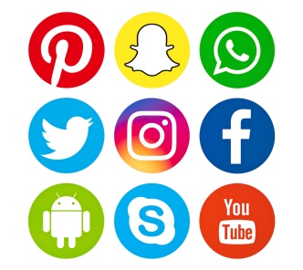
Facebook users skew female and live in urban areas, while Instagram users also tend to be female and Twitter users tend to be male. Kayla Carmicheal takes a deep dive into the demographics of these and other platforms, including Snapchat, TikTok, YouTube, Reddit and LinkedIn, to help marketers maximize their return on investment.
HubSpot 1/15/20
https://blog.hubspot.com/marketing/state-of-social-media-demographics
Image credit:
https://www.channelpartnersonline.com/files/2017/08/Social-Media-Icons.jpg

