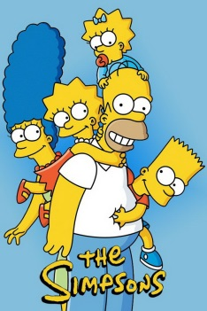
‘The Simpsons’ Shatters Another TV Milestone
“The Simpsons” is about to break yet another record — surpassing “Gunsmoke” for the most episodes of a prime-time scripted series in TV history.
The New York Post 4.25.18
https://nypost.com/2018/04/25/the-simpsons-shatters-another-tv-milestone/
Image credit:
https://fontmeme.com/images/The-Simpsons-TV-Series.jpg

