The Technologies PR Pros Need to Master
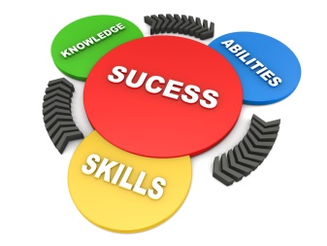
Today's communications pros need to know how to integrate social or digital media into PR campaigns and be prepared to utilize "big data, artificial intelligence and a wide array of tech," writes Ted Kitterman. He also suggests mastering personal social media to stand apart from peers, noting "a strong personal brand is a key differentiator in an industry that doesn't have a lot of rigorous measures in place to police membership."
PR Daily 1.15.20
https://www.prdaily.com/how-pr-pros-must-adapt-to-new-technologies/
Image credit:
https://www.culpwrit.com/wp-content/uploads/2016/07/PR-skills.jpg

