The Top 10 Esports Orgs In The World In 2022
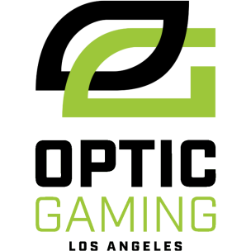
OpTic Gaming climbed over FaZe Clan to take the top spot after winning the Halo World Championship in October. Using a points metric, Nerd Street’s monthly rankings seek to objectively quantify the best orgs across all esports for 2022 by measuring success in 10 games: League of Legends, VALORANT, Counter-Strike: Global Offensive, Rocket League, Apex Legends, Dota 2, Rainbow Six: Siege, Call of Duty, Overwatch and Halo.
NerdStreet 12.1.22
https://nerdstreet.com/news/2022/12/top-10-esports-orgs-in-the-world-right-now

